Problem A
a.c, a.cpp, a.java
a.in, a.out
Background
Being well known for its highly innovative products, Merck would deﬁnitely be a good target for industrial espionage. To protect its brand-new research and development facility the company has installed the latest system of surveillance robots patrolling the area. These robots move along the walls of the facility and report suspicious observations to the central security ofﬁce. The only ﬂaw in the system a competitor’s agent could ﬁnd is the fact that the robots radio their movements unencrypted. Not being able to ﬁnd out more, the agent wants to use that information to calculate the exact size of the area occupied by the new facility. It is public knowledge that all the corners of the building are situated on a rectangular grid and that only straight walls are used. Figure 1 shows the course of a robot around an example area.
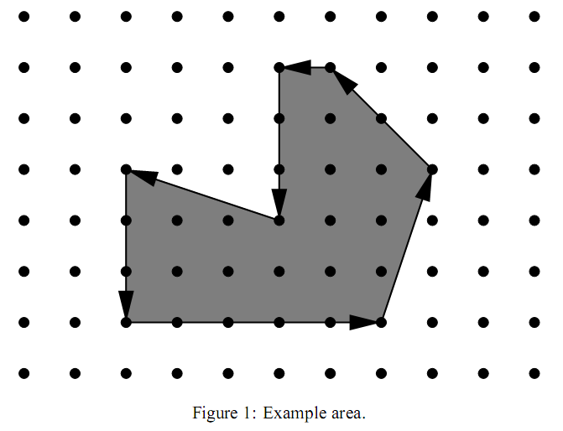
Problem
You are hired to write a program that calculates the area occupied by the new facility from the movements of a robot along its walls. You can assume that this area is a polygon with corners on a rectangular grid. However, your boss insists that you use a formula he is so proud to have found somewhere. The formula relates the number I of grid points inside the polygon, the number E of grid points on the edges, and the total area A of the polygon. Unfortunately, you have lost the sheet on which he had written down that simple formula for you, so you need to ﬁnd the formula yourself.

Input
The ﬁrst line contains the number of scenarios.
For each scenario, you are given two numbers : the number I of grid points inside the polygon and the number E of grid points on the edges.
Output
The output for every scenario begins with a line containing “Scenario #i:”, where i is the number of the scenario starting at 1. Then print a single line containing the area A rounded to one digit after the decimal point.
Sample input
2
0 4
12 16
Sample output
Scenario #1:
1.0
Scenario #2:
19.0

